***Final project report***

Html, Css, Javascript (E-commerce website)

**MANORAMA INSTITUTE Of MANAGEMENT &TECHNOLOGY**

**Ladamda, fatehpur sikri road(283105)**



SESSION (2023-24)

**DEPARTMENT OF COMPUTER APPLICATION**

**BACHOLAR OF COMPUTER APPLICATION (BCA)**

**DR. BHIMRAO AMBEDHAKAR UNIVERSITY**

**(AGRA)**

**PROJECT REPORT ON E-commerce website BY HTML, CSS, JAVASCRIPT**

***SUBMITTED BY------ Neha solanki***

***ROLL-NO=21052550011009***

**preface**

***E***

This project “online E-Commerce Shopping website” provides multiple benefits to the consumers in form of availability of goods at lower cost, wider choice and saves time. Online shopping is a web based application intended for online retailers. The application provides a drag and drop features so that a user can add a product to the shopping cart.

This application provides a complete description about any product also view reviews and ratings. Online shopping system 24*7 availability.

**DECLARATION**

I hereby declare that this project report entitled

“**Online E-commerce website”** submitting by me for the partial fulfilment of the requirement for the award of Bachelor in Computer Application (BCA) is an authentic work completed by **Neha Solanki**. The report being submitted has not been submitted earlier for the award of degree or diploma to our institute.

Date:

Signature:

Name: NEHA SOLANKI

**CERTIFICATE**

This is certified that **NEHA SOLANKI** student of BCA (VI semester) of **MANORAMA Institute Of Management & Technology**, has successfully completed the project work entitled **“online shopping system”** under the guidance of prof. **HARSH SHARMA** is a bonafide piece of work carried out at Manorama institute of management & technology.

The project entitled “E-commerce shopping website” developed by NEHA SOLANKI in the Manorama institute of management & technology and he/she had done his/her laboratory work during the tenure of the project with the guide to complete the project. All the prescribed certificates are attached after the completion of all the formalities of the paper work as per schedule, including examination.

**Place: Agra**

Signature

**Introduction**

**i**

Online shopping is a form of electronic commerce which allows customers to directly buy goods and products from a seller over the internet through using web browser or a mobile app. Consumers find a product of interest by visiting the website of the retailer directly or by searching among alternative vendors using a shopping search engine. Customers can shop online using a range of different computers and devices, including desktop computer, laptops, tablets and smartphones. Online shopping is becoming increasingly popular for different varieties of clothes and other things. Customers can get full information about the product with its reviews. Customers can buy products according to your need in reasonable price and different varieties and categories under our budgets. Now a day people life style is different. People feel uncomfortable and time consuming for going crowded markets. So, E-commerce shopping website is a soon as it saves lot of time. Online shopping is a process whereby customers directly buy things and products goods and services etc. shoppers can visit online stores an intermediary service over the internet. Customers can visit online stores from the comfort of their homes and anywhere on your phones and laptops etc. online stores usually available 24 hours a day and many customers have internet access both at work and at home. So it is very convenient to shop products online. The metaphor of an online catalog is also used, by analogy with mail order catalogs. All types of stores have retail web sites, including those that do and do not also have physical storefronts and paper catalogs. Online shopping is a form of electronic commerce used for business-to-business (B2B) and business-to-consumer (B2C) transactions. If an intermediary service is present the process is called electronic commerce. An online shop, e-shop, e-store, internet shop, web-shop, web-store, online store, or virtual store evokes the physical analogy of buying products or services  at a bricks-and-mortar  retailer  or in a shopping mall.

**Scope of project**

….Online stores usually available 24 hour a day, and many customer have internet access at both work and home.

Searching and browsing an online catalog can be faster than the browsing the aisles of a physical store.

The internet has made shopping an almost effortless task.

Other establishments, such as internet cafes and school provides access as well. A visit to a conventional retail store requires travel and must take place during the business hours.

One can avoid crowded malls resulting in long lines, and no parking.

Customer with dial-up internet connection rather than broadband have much longer load times to content rich websites……

**Project Objectives**

1. **Manage the shopping details**: The whole system of online shopping manage the detail of each shopping done by the customers. They extract the product details of what consumers shopped.
2. **Manage the payment details:** In online shopping, customers get many options for mode of payments. Websites give them the option of online payment through debit or credit cards. Customers have also the option of net banking or cash on delivery payment option. It is the objective of an online shopping system to manage all the payment details of each product.
3. **Generate the information of customers and products**: Online shopping system manages the whole information about the customers and the purchased products.
4. **Reduce the cost of management:** Online shopping or digital shopping help in reducing the management cost of products.

**Acknowledgement**

Firstly we would like to express our gratitude to our guide **MR. Harsh Sharma** sir & other faculty member for giving us wonderful opportunity to work on the project. We are very thankful to him who was always ready to lend their helping hand to us. This project has giving us fair exposure to some of the very interesting features of “**Online E-commerce website”** and **“javascript”** along beyond doubt it will help us in the short or long run. We are very grateful to introducing me to some of very exciting features of **“online e-commerce website”.**

We are also thankful to all my teachers of **MANORAMA INSTITUTE OF MANAGEMENT & TECHNOLOGY.** And in the end, we would like to thank all those who helped me during this project.

**Singature:**

Name:

Neha Solanki

**Entity Relationship Diagram**

An entity relationship diagram is also known as an entity relationship model. The key here is to graphically depict the relationship between people, objects, concepts or events in an IT system. It also represents the contacts in the set of entities stored in the database. An E-R diagram is a logical structure of a database that defines organizations, their properties, and the relationship between them. ER is also used to design the database.

The E-R diagram communicates all the entities, relationships and attributes. It has four main parts. Entities are the physical existence and the existence of a set of conceptual objects. It is represented by a rectangle symbol. Entities that do not have strong relationships are called weak entities. The characteristics of the object represent by the oval symbol. The primary key enables the institutional integrity of the table.

**E-R diagram**

HAS

HAS

Product

Customers

Online Shopping

**Technology used to develop website**

**HTML:** HTML stands for Hyper Text Markup Language. It's the standard markup language for creating web pages and web applications. HTML describes the structure of a web page semantically and originally included cues for the appearance of the document. HTML elements are the building blocks of HTML pages, and they are represented by tags. These tags label pieces of content such as headings, paragraphs, images, links, and more. Web browsers use HTML to interpret and render the content of web pages for users.

**CSS:** CSS, or Cascading Style Sheets, is a style sheet language used to describe the presentation of a document written in HTML or XML (including XML dialects such as SVG, Math ML, etc.). CSS describes how elements should be rendered on screen, in print, or in other media.

CSS separates the presentation style of a web page from its content, allowing developers to define styles such as layout, colors, fonts, and spacing independently of the HTML structure. This separation of concerns makes it easier to maintain and update the visual appearance of a website.

**JAVASCRIPT:** JavaScript (JS) is a high-level programming language that is commonly used to add interactivity and dynamic behavior to web pages. It was initially developed for use in web browsers, but it is now widely used for server-side development as well, thanks to frameworks like Node.js.

JavaScript allows developers to manipulate the content and structure of web pages in real-time, enabling features such as form validation, animations, interactive maps, and much more. It is a versatile language that can be used for both client-side and server-side scripting.

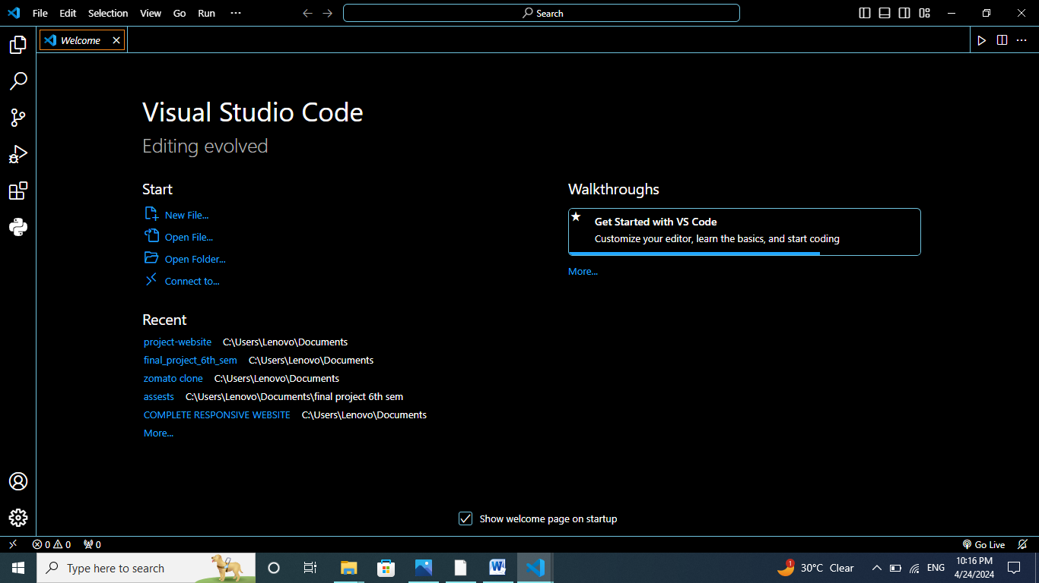

**Software used to design website**

To design a website, you’ll need a combination of software tool for various tasks such as graphic design, coding, content management and more.

The specific software you choose can depend on you skills, preferences, and the complexity of your

project. Here is some essential type of software you might consider.

**VS CODE:** VS Code, short for Visual Studio Code, is a free source-code editor developed by Microsoft for Windows, Linux, and macOS. It's designed to be lightweight yet powerful, with features tailored for web development (HTML, CSS, JavaScript), but it supports a wide range of other programming languages through extensions.

VS Code offers features like syntax highlighting, intelligent code completion, debugging support, Git integration, and customizable themes and extensions. It has gained significant popularity among developers due to its speed, ease of use, and extensive customization options. Additionally, it's highly extensible, allowing users to install a variety of extensions to enhance their workflow for specific programming languages or tasks.

**Project layout**

|  |  |
| --- | --- |
| **section** | **Description** |
| **Product Image** | Display a thumbnail or small image of the product. This gives users a visual representation of what they are browsing. |
| **Product Name**: | Clearly list the name of the product. This should be a clickable link that takes the user to the product details page |
| **Description** | Provide a brief description of the product. Keep it concise but informative enough for users to understand the key features. |
| **Price** | Display the price of the product. Make sure it's prominently visible to users. |
| **Add to Cart**: | Include a button or link that allows users to add the product to their shopping cart. This should be easily accessible and stand out from the rest of the information. |

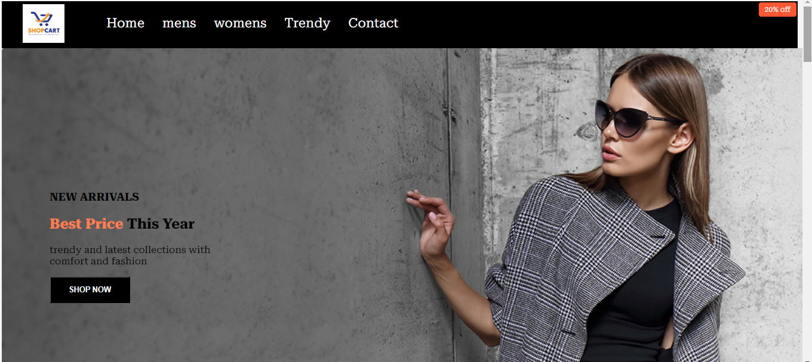**Home page:**

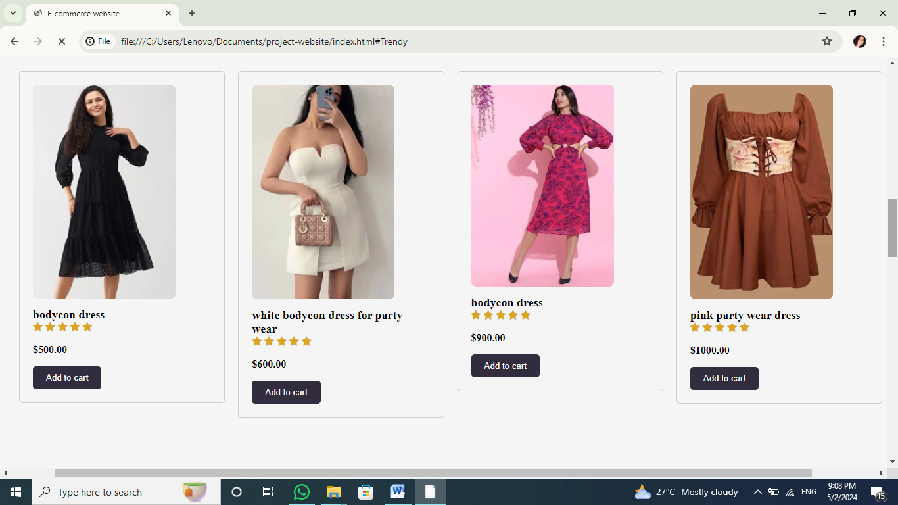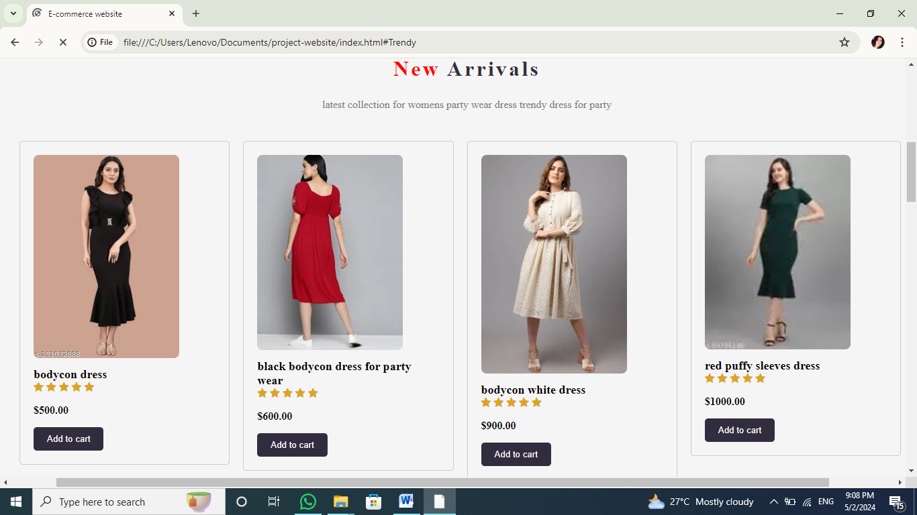

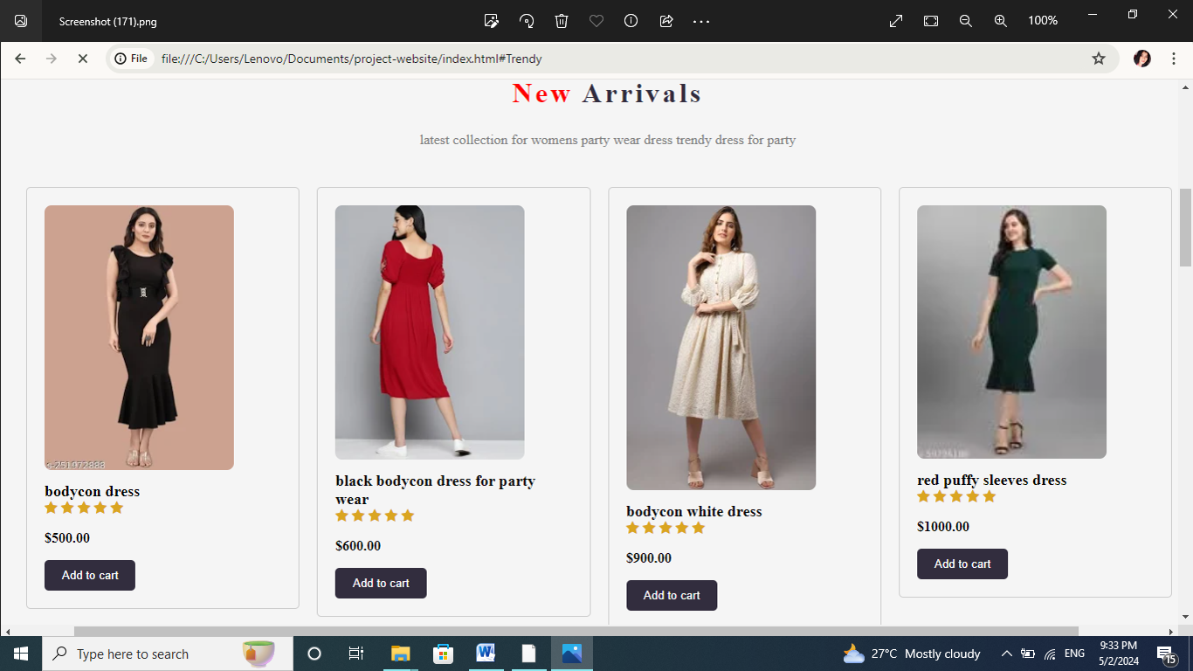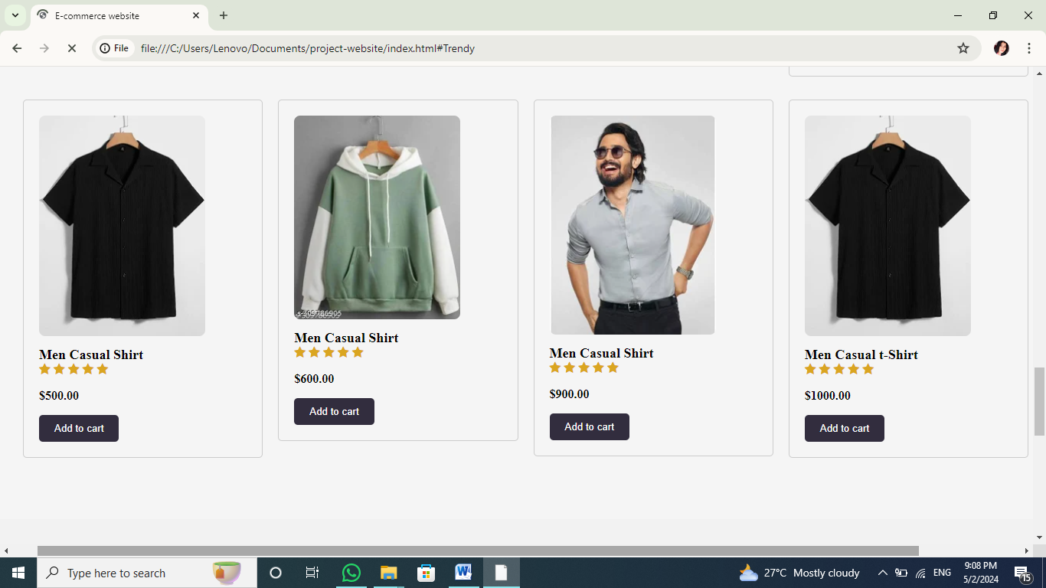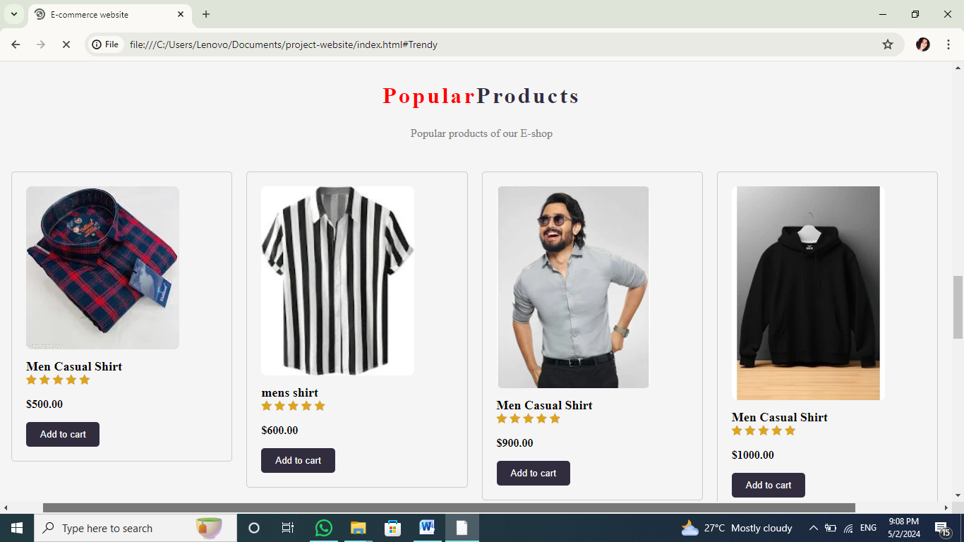

**Website home page**

**New Arrivals**

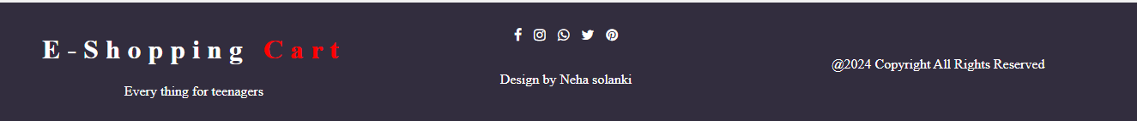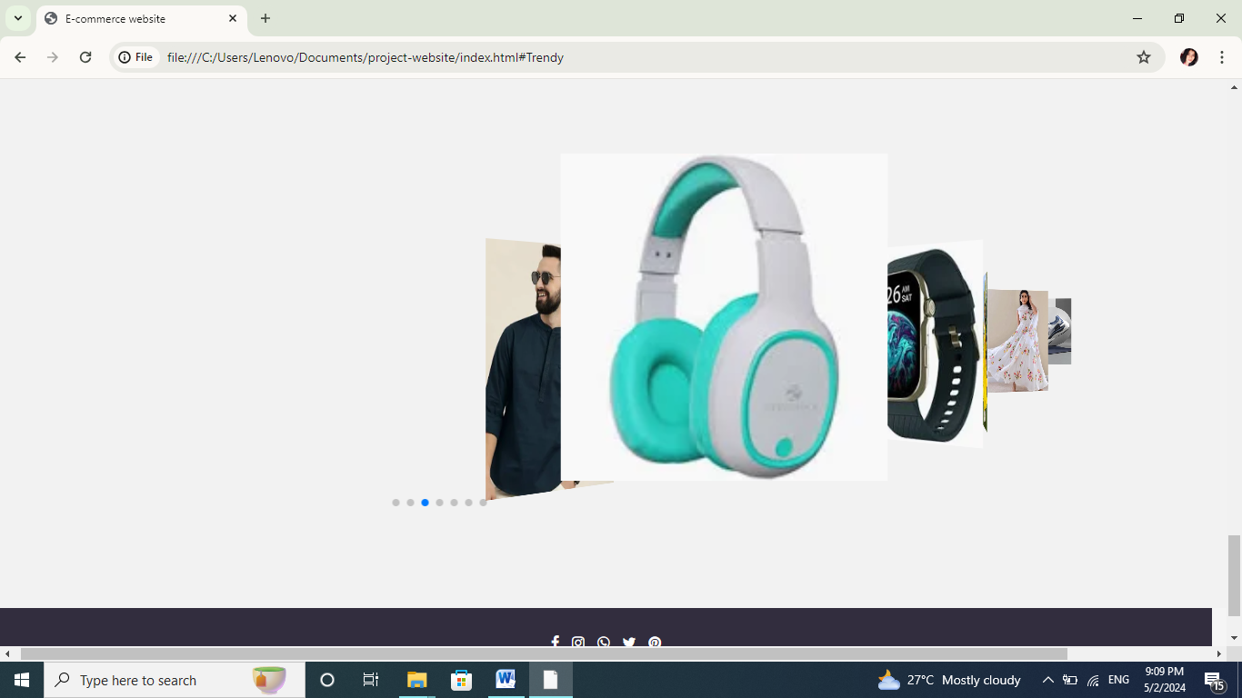

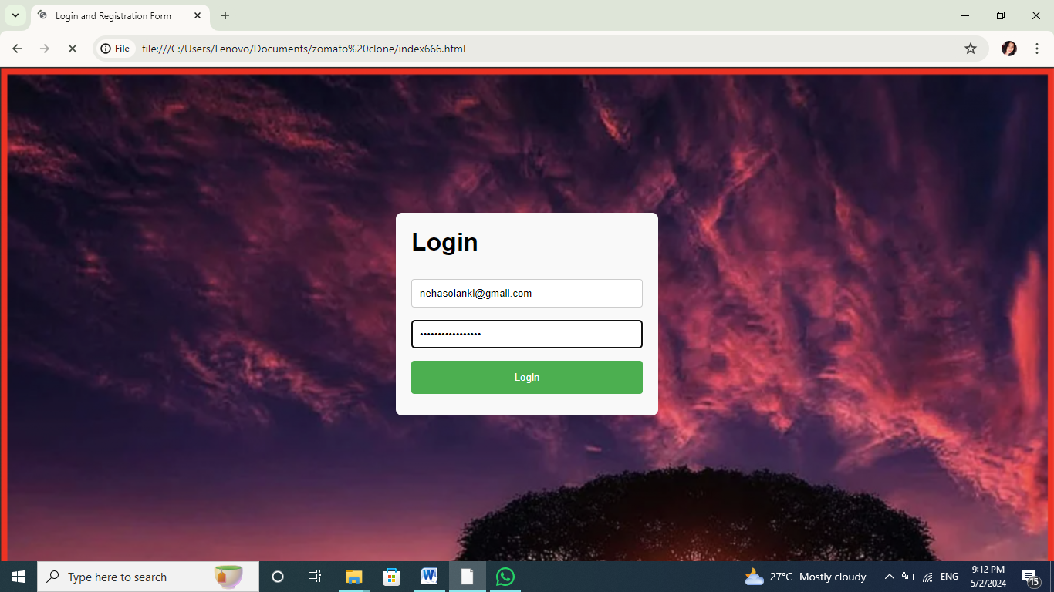**Login page:**

Click on login button then this interface is shown on window.

Fill the form to login our shopping account in this website.

**Coding section of Home page:**

<!DOCTYPE html>

<html lang="en">

<head>

<meta charset="UTF-8">

<meta name="viewport" content="width=device-width, initial-scale=1.0">

<title>E-commerce website</title>

<link rel="stylesheet" href="C:\Users\Lenovo\Documents\project-website\style.css">

<script src="script.js"></script>

<link rel="stylesheet" href=<https://cdnjs.cloudflare.com/ajax/libs/font-awesome/4.7.0/css/font-awesome.min.css>”>

<link rel="preconnect" href=<https://fonts.googleapis.com>>

<link rel="preconnect" href=https://fonts.googleapis.com>

<link rel="preconnect" href=”https://fonts.gstatic.com" crossorigin”>

<link href="https://fonts.googleapis.com/css2?family=Akaya+Kanadaka&family=Roboto+Serif:ital,opsz,wght@0,8..144,100..900;1,8..144,100..900&family=Roboto:ital,wght@0,100;0,300;0,400;0,500;0,700;0,900;1,100;1,300;1,400;1,500;1,700;1,900&display=swap" rel="stylesheet">

<link rel="stylesheet"href="https://cdn.jsdelivr.net/npm/swiper@11/swiper-bundle.min.css"/>

</head>

<body>

<header>

<nav id="navbar">

<div id="logo">

<img src="images\logo.jpg" alt="logo">

</div>

<ul>

<li class="class"><a href="">Home</a></li>

<li class="class"><a href="#mens">mens</a></li>

<li class="class"><a href="#womens">womens</a></li>

<li class="class"><a href="#Trendy">Trendy </a></li>

<li class="class"><a href="">Contact </a></li>

</ul>

</nav>

<section id="home">

<div class="container">

<h3>NEW ARRIVALS</h3>

<h2><span>Best Price</span> This Year</h2>

<p>trendy and latest collections with <br>comfort and fashion</p>

<button>Shop Now</button>

</div>

<div class="left">

<a href="file:///C:/Users/Lenovo/Documents/zomato%20clone/index666.html">Register</a> OR

<a href="file:///C:/Users/Lenovo/Documents/zomato%20clone/index666.html">Login</a>

</div>

</section>

</section>

<!-- featured end -->

</header>

<body>

<!-- latest start -->

<section class="latest" id="womens">

<div class="Product-Intro">

<h1> New <span>Arrivals</span></h1>

<p>latest collection for womens party wear dress trendy dress for party</p>

</div>

<div class="card-row">

<div class="card">

<img src="images\meee.webp" alt="Image 1">

<div class="card-title">bodycon dress</div>

<div class="star">

<span>

<i class="fa fa-star"></i>

<i class="fa fa-star"></i>

<i class="fa fa-star"></i>

<i class="fa fa-star"></i>

<i class="fa fa-star"></i>

</span>

<p>$500.00</p>

</div>

<div class="buttons">

<button>Add to cart</button>

</div>

</div>

<div class="card">

<img src="images\b3.webp" alt="Image 2">

<div class="card-title">black bodycon dress for party wear</div>

<div class="star">

<span>

<i class="fa fa-star"></i>

<i class="fa fa-star"></i>

<i class="fa fa-star"></i>

<i class="fa fa-star"></i>

<i class="fa fa-star"></i>

</span>

<p>$600.00</p>

</div>

<div class="buttons">

<button>Add to cart</button>

</div>

</div>

<div class="card">

<img src="images\b5.webp" alt="Image 3">

<div class="card-title">bodycon white dress</div>

<div class="star">

<span>

<i class="fa fa-star"></i>

<i class="fa fa-star"></i>

<i class="fa fa-star"></i>

<i class="fa fa-star"></i>

<i class="fa fa-star"></i>

</span>

<p>$900.00</p>

</div>

<div class="buttons">

<button>Add to cart</button>

</div>

</div>

<div class="card">

<img src="images\b7.webp" alt="Image 4">

<div class="card-title">red puffy sleeves dress</div>

<div class="star">

<span>

<i class="fa fa-star"></i>

<i class="fa fa-star"></i>

<i class="fa fa-star"></i>

<i class="fa fa-star"></i>

<i class="fa fa-star"></i>

</span>

<p>$1000.00</p>

</div>

<div class="buttons">

<button>Add to cart</button>

</div>

</div>

</div>

<div class="card-row">

<div class="card">

<img src="images\www.webp" alt="Image 1">

<div class="card-title">bodycon dress</div>

<div class="star">

<span>

<i class="fa fa-star"></i>

<i class="fa fa-star"></i>

<i class="fa fa-star"></i>

<i class="fa fa-star"></i>

<i class="fa fa-star"></i>

</span>

<p>$500.00</p>

</div>

<div class="buttons">

<button>Add to cart</button>

</div>

</div>

<div class="card">

<img src="images\b1.webp" alt="Image 2"> <div class="card-title">white bodycon dress for party wear</div>

<div class="star">

<span>

<i class="fa fa-star"></i>

<i class="fa fa-star"></i>

<i class="fa fa-star"></i>

<i class="fa fa-star"></i>

<i class="fa fa-star"></i>

</span>

<p>$600.00</p>

</div>

<div class="buttons">

<button>Add to cart</button>

</div>

</div>

<div class="card">

<img src="images\b2.webp" alt="Image 3">

<div class="card-title">bodycon dress</div>

<div class="star">

<span>

<i class="fa fa-star"></i>

<i class="fa fa-star"></i>

<i class="fa fa-star"></i>

<i class="fa fa-star"></i>

<i class="fa fa-star"></i>

</span>

<p>$900.00</p>

</div>

<div class="buttons">

<button>Add to cart</button>

</div>

</div>

<div class="card">

<img src="images\b6.webp" alt="Image 4">

<div class="card-title">pink party wear dress</div>

<div class="star">

<span>

<i class="fa fa-star"></i>

<i class="fa fa-star"></i>

<i class="fa fa-star"></i>

<i class="fa fa-star"></i>

<i class="fa fa-star"></i>

</span>

<p>$1000.00</p>

</div>

<div class="buttons">

<button>Add to cart</button>

</div>

</div>

</div>

<latest>

<!-- latest end -->

<!-- popular products start-->

<section class="Latest" id="mens>

<div class="Product-Intro">

<h1>Popular<span>Products</span></h1>

<p> Popular products of our E-shop </p>

</div>

<div class="card-row">

<div class="card">

<img src="images\1111.webp" alt="Image 1">

<div class="card-title">Men Casual Shirt</div>

<div class="star">

<span>

<i class="fa fa-star"></i>

<i class="fa fa-star"></i>

<i class="fa fa-star"></i>

<i class="fa fa-star"></i>

<i class="fa fa-star"></i>

</span>

<p>$500.00</p>

</div>

<div class="buttons">

<button>Add to cart</button>

</div>

</div>

<div class="card">

<img src="images\4.webp" alt="Image 2"> <div class="card-title">mens shirt</div>

<div class="star">

<span>

<i class="fa fa-star"></i>

<i class="fa fa-star"></i>

<i class="fa fa-star"></i>

<i class="fa fa-star"></i>

<i class="fa fa-star"></i>

</span>

<p>$600.00</p>

</div>

<div class="buttons">

<button>Add to cart</button>

</div>

</div>

<div class="card">

<img src="images\me2.webp" alt="Image 3">

<div class="card-title">Men Casual Shirt</div>

<div class="star">

<span>

<i class="fa fa-star"></i>

<i class="fa fa-star"></i>

<i class="fa fa-star"></i>

<i class="fa fa-star"></i>

<i class="fa fa-star"></i>

</span>

<p>$900.00</p>

</div>

<div class="buttons">

<button>Add to cart</button>

</div>

</div>

<div class="card">

<img src="images\me6.webp" alt="Image 4">

<div class="card-title">Men Casual Shirt</div>

<div class="star">

</div>

<div class="buttons">

<button>Add to cart</button>

</div>

</div>

</div>

<div class="card-row">

<div class="card">

<img src="images\sssst.webp" alt="Image 1">

<div class="card-title">Men Casual Shirt</div>

<div class="star">

<span>

<i class="fa fa-star"></i>

<i class="fa fa-star"></i>

<i class="fa fa-star"></i>

<i class="fa fa-star"></i>

<i class="fa fa-star"></i>

</span>

<p>$500.00</p>

</div>

<div class="buttons">

<button>Add to cart</button>

</div>

</div>

<div class="card">

<img src="images\me7.webp" alt="Image 2">

<div class="card-title">Men Casual Shirt</div>

<div class="star">

<span>

<i class="fa fa-star"></i>

<i class="fa fa-star"></i>

<i class="fa fa-star"></i>

<i class="fa fa-star"></i>

<i class="fa fa-star"></i>

</span>

<p>$600.00</p>

</div>

<div class="buttons">

<button>Add to cart</button>

</div>

</div>

<div class="card">

<img src="images\me2.webp" alt="Image 3">

<div class="card-title">Men Casual Shirt</div>

<div class="star">

<span>

<i class="fa fa-star"></i>

<i class="fa fa-star"></i>

<i class="fa fa-star"></i>

<i class="fa fa-star"></i>

<i class="fa fa-star"></i>

</span>

<p>$900.00</p>

</div>

<div class="buttons">

<button>Add to cart</button>

</div>

</div>

<div class="card">

<img src="images\tshirt.webp" alt="Image 4" <div class="card-title">Men Casual t-Shirt</div>

<div class="star">

<span>

<i class="fa fa-star"></i>

<i class="fa fa-star"></i>

<i class="fa fa-star"></i>

<i class="fa fa-star"></i>

<i class="fa fa-star"></i>

</span>

<p>$1000.00</p>

</div>

<div class="buttons">

<button>Add to cart</button>

</div>

</div>

</div>

</section>

<!-- popular products end -->

<section class="Trends" id="Trendy">

<div class="Product-Intro">

<h1> Top<span>Trends</span></h1>

<p>Top Trending collections according to trend</p>

</div>

<div class="swiper mySwiper">

<div class="swiper-wrapper">

<div class="swiper-slide">

<img src="images\tp1.webp" alt="">

</div>

<div class="swiper-slide">

<img src="images\tp2.webp" alt="">

</div>

<div class="swiper-slide">

<img src="images\tp3.webp" alt="">

</div>

<div class="swiper-slide">

<img src="images\tp4.webp" alt="">

</div>

<div class="swiper-slide">

<img src="images\444.jpg" alt="">

</div>

<div class="swiper-slide">

<img src="images\999.webp" alt="">

</div>

<div class="swiper-slide">

<img src="images\shoesssss.webp" alt="">

</div>

<div class="swiper-pagination"></div>

</div>

</section>

<!-- <section>

<div class="letter">

<div class="letter text">

<h1>Sign Up for search more</h1>

</div>

<div class="inp">

<input type="text" placeholder="Enter Email">

<button>Sign Up</button>

</div>

</div>

</section> -->

<footer>

<div>

<h1>E-Shopping <span>Cart</span></h1>

<p>Every thing for teenagers</p>

</div>

<div>

<i class="fa fa-facebook"></i>

<i class="fa fa-instagram"></i>

<i class="fa fa-whatsapp"></i>

<i class="fa fa-twitter"></i>

<i class="fa fa-pinterest"></i>

<p><br> Design by Neha solanki</p>

</div>

<div>

<P>

@2024 Copyright All Rights Reserved

</P>

</div>

</footer>

<script src="https://cdn.jsdelivr.net/npm/swiper@11/swiper-bundle.min.js"></script>

<script>

var swiper = new Swiper(".mySwiper", {

effect: "coverflow",

grabCursor: true,

centeredSlides: true,

slidesPerView: "auto",

coverflowEffect: {

rotate: 50,

stretch: 0,

depth: 1200,

modifier: 1,

slideShadows: false,

},

pagination: {

el: ".swiper-pagination",

},

});

</script>

</body>

</html>

**CSS Code:**

{

padding:0;

margin:0;

box-sizing: border-box;}

body{

scroll-behavior: smooth;

font-family: "Roboto Serif";

background-color:whitesmoke;

/* background-image: url(https://encrypted-tbn0.gstatic.com/images?q=tbn:ANd9GcQvaYKjQTNA-NqRGo4IR2EBEZUD5ZPbTz9iaeYpO7QfSA&s);

background-size: cover;

height: 100%;

Center and scale the image nicely */

/* background-position: center; */

/* background-repeat: no-repeat; */ */

}

:root{

--primary:rgba(255, 0, 0);

--secondary:rgba(15,10,29,0.849);

--light:rgb(128, 128, 128);

}

header{

width: 100%;

height: 100vh;

}

#navbar{

display: flex;

position: sticky;

}

#navbar::before{

content: "";

background-color: black;

position: absolute;

height: 100%;

width: 100%;

z-index: -1;

}

/*navigation bar: logo and image*/

#logo{

margin: 5px 15px;

}

#logo img{

height: 65px;

width: 70px;

margin-left: 20px;

}

#navbar ul {

display: flex;

}

#navbar ul li

list-style: none;

font-size: 1.2rem;

}

#navbar ul li a{

font-size: 22px;

color: white;

display: block;

padding: 5px 10px;

margin: 3px 5px;

border-radius: 20px;

text-decoration: none;

}

#navbar ul li a :hover{

color: black;

background-color: white;

font-weight: 700;

}

/* home section */

#home{

display: flex;

flex-direction: column;

height: 520px;

padding: 4px 80px;

justify-content: space-between;

align-items: center;

}

#home::before{

content: "";

position: absolute;

height: 650px;

width: 100%;

z-index: -1;

opacity: 0.75;

}

#home h1{

font-size: 3.2rem;

margin-top: 100px;

margin-bottom: 8px;

font-family: "lobster" , sans-serif;

font-weight: 250;

}

#home span {

color: coral;

}

#home button{

font-size: 0.8rem;

font-weight: 700;

outline: none;

background-color: black;

color: aliceblue;

cursor: pointer;

padding: 13px 30px;

text-transform: uppercase;

transition: 0.3sec ease;

}

#home {

width: 100%;

/* background-image:url(https://images.unsplash.com/photo-1513094735237-8f2714d57c13?q=80&w=1470&auto=format&fit=crop&ixlib=rb-4.0.3&ixid=M3wxMjA3fDB8MHxwaG90by1wYWdlfHx8fGVufDB8fHx8fA%3D%3D); */

background-image: url(https://raw.githubusercontent.com/tech2etc/Build-Ecommerce-Website-With-HTML-CSS-JavaScript/cae7b058286bb2574b3d61f4d634b4505b6bff84/img/banner/2.jpg);

height: 100vh;

background-size: cover;

background-position: top center ;

display: flex;

flex-direction: column;

justify-content: center;

align-items: flex-start;

}

.latest{

padding: 80px 100px;

}

.Product-Intro{

text-align: center;

}

.Product-Intro h1{

color: var(--primary);

letter-spacing: 0.2rem;

font-size: 2rem;

font-weight: bolder;

}.Product-Intro h1 span{

color:var(--secondary);

}

.Product-Intro p{

color: grey;

margin: 15px 0px;

}

.card-row {

display: flex;

}

.card {

margin-right: 20px;

padding: 20px;

border: 1px solid #ccc;

border-radius: 5px;

width: 100%;

height: 100%;

width: calc(25% - 20px); /* 25% width with margin */

transition: 0.3 ease-in-out;

}

.card img {

width: 80%;

border-radius: 8px;

}

.card-title {

margin-top: 10px;

font-size: 18px;

font-weight: bold;

}

/* .buttons {

margin-top: 10px;

color: white;

background-color: var(--secondary);

} */

.card p{

font-weight: bold;

font-size: 1rem;

}

.card span{

color: goldenrod;

}

.card:hover{

transform: scale(1.05);

}

.card::after{

content: "20% off"; /* Text content */

position: absolute; /* Position absolutely within the card */

top: 10px; /* Adjust top position */

right: 10px; /* Adjust right position */

background-color: #ff5733; /* Background color of the label */

color: #ffffff; /* Text color of the label */

padding: 5px 10px; /* Padding for the label */

border-radius: 5px; /* Border radius for rounded corners */

font-size: 12px; /* Font size of the label */

}

.card button {

background-color: var(--secondary); /* Button background color */

color: #ffffff; /* Button text color */

border: none; /* Remove button border */

padding: 10px 20px; /* Button padding */

border-radius: 5px; /* Border radius for rounded corners */

cursor: pointer; /* Change cursor to pointer on hover */

}

.card button:hover {

background-color:var(--primary); /* Button background color on hover */

}

.Trends{

padding: 50px 100px;

background-color: rgba(0,0,0,0.01);

}

.Trends .swiper {

width: 100%;

padding: 50px;

}

.Trends .swiper-slide {

background-position: center;

background-size: cover;

width: 400px;

height: 400px;

}

.Trends .swiper-slide img {

display: block;

width: 90%;

height: 90;

}

footer{

background-color: var(--secondary);

color: white;

display: flex;

justify-content: space-around;

align-items: center;

flex-wrap: wrap;

text-align: center;

padding: 1rem;

}

.fa-instagram:hover{color: rgb(255, 0, 98);}

.fa-facebook:hover{color: rgb(0, 38, 255);}

.fa-twitter:hover{color: rgb(0, 195, 255);}

.fa-whatsapp:hover{color: rgb(51, 255, 0);}

.fa-pinterest:hover{color: rgb(255, 0, 0);}

footer div{

flex-basis: 30%;

}

footer h1{

letter-spacing: 0.5rem;

}

footer h1 span{

color: var(--primary);

}

footer p{

font-size: 1rem;

}

footer i{

margin: 0px 5px;

}

footer{

position: fixed;

left: 0;

bottom: 0;

display: flex;

width: 100%;

height: 370px;

}

section{

display: flex;

flex-direction: column;

justify-content: flex-end;

gap: 30px;

padding-bottom: 80px;

padding-left: 60px;

width: 100%

@media only screen and (max-width:769px){

.nav1{

position: relative;

z-index:2;

background-color: white;

}

}

/* .letter{

display: flex;

justify-content: space-between;

color: white;

background-color: blue;

padding: 20px;

}

.inp{

display: flex;

}

.inp input{

width: 330px;

height: 33px;

outline: none;

font-size: 18px;

}

.inp button{

width: 100px;

height: 33px;

background-color: var(--secondary);

color: white;

} */

@media only screen and (max-width:769px){

.nav1{

position: relative;

z-index: 2;

background-color: white;

}

.right i{

font-size: 15px;

margin: 0px 5px;

}

.nav2{

width: 100%;

height: 80px;

}

.nav2 .nav2-left i{

margin-left: 0px;

}

.nav2 .nav2-center h1{

font-size: 1.2rem;

letter-spacing: 1px;

}

.nav2 .nav2-center p{

color: grey;

font-size: 8px;

margin-top: 5px;

}

.nav2 .nav2-right i{

margin: 0px 5px;

}

.nav3{

display: inline-flex;

}

.featured{

background-attachment: fixed;

}

.latest{

padding: 0px 50px;

}

.Product-Intro{

text-align: center;

}

.Product-Intro h1{

color: var(--primary);

letter-spacing: 0.2rem;

font-size: 2rem;

font-weight: bolder;

}.Product-Intro h1 span{

color:var(--secondary);

}

.Product-Intro p{

color: grey;

margin: 10px 0px;

}

.card-row {

display: flex;

}

.card {

margin-right: 20px;

padding: 50px;

border-color: black;

}

.card img {

width: 100%;

border-radius: 8px;

}

.card-title {

margin-top: 10px;

font-size: 18px;

font-weight: bold;

}

/* .buttons {

margin-top: 10px;

color: white;

background-color: var(--secondary);

} */

.card p{

font-weight: bold;

font-size: 1rem;

}

.card span{

color: goldenrod;

}

.card:hover{

transform: scale(1.05);

}

.card::after{

content: "20% off"; /* Text content */

position: absolute; /* Position absolutely within the card */

top: 10px; /* Adjust top position */

right: 10px; /* Adjust right position */

background-color: #ff5733; /* Background color of the label */

color: #ffffff; /* Text color of the label */

padding: 5px 10px; /* Padding for the label */

border-radius: 5px; /* Border radius for rounded corners */

font-size: 12px; /* Font size of the label */

}

.card button {

background-color: var(--secondary); /* Button background color */

color: #ffffff; /* Button text color */

border: none; /* Remove button border */

padding: 10px 20px; /* Button padding */

border-radius: 5px; /* Border radius for rounded corners */

cursor: pointer; /* Change cursor to pointer on hover * }

**Conclusion**

We have successfully implemented the site. With the help of various links & tools. We have k